**St. Andrews Institute of Technology & Management,**

**Gurgaon**



**Department of Computer Science Engg.**

A

Training Report

Of

**Minor Project**

On

**Web Designing**

**B.Tech (CSE 3rd Sem)**

**Session- Aug to Dec 2018**

**Submitted To:- Submitted By:-**

**St. Andrews Institute of Technology & Management farrukhnagar, Gurugram**

**TO WHOM IT MAY CONCERN**

I hereby certify that “_____________________” Roll No ___________ of St.Andrew’s Institute of Technology and Management, Gurgaon, has undergone training from ____________ to ________________at our College to fulfill the requirements for the award of degree of B.Tech. (Branch .He/She works on _____________ project during the training under the supervision of __________________. During his tenure with us we found him sincere and hard working.

Wishing him/her a great success in the future.

Signature of the Student

Signature of the Director (S) Signature of the HOD (S)

 (Seal of Organization)

|  |
| --- |
|  |
|  |  |

**ACKNOWLEDGEMENT**

The authors are highly grateful to the Dr. Jugnesh , Director, St.Andrew’s Institute of Technology and Management, Gurgaon, for providing this opportunity to carry out the Summer Internship training at _________________.

The constant guidance and encouragement received from Director T&P, SAITM, Gurgaon, has been of great help in carrying out the project work and is acknowledged with reverential thanks.

The authors would like to express a deep sense of gratitude and thanks profusely to _ ___________Director/CEO of Company, . Without the wise counsel and able guidance, it would have been impossible to complete the report in this manner.

The help rendered by [Faculty In charge of Training ], Supervisor (________________) for experimentation is greatly acknowledged.

The author express gratitude to other faculty members of Computer Science Engineering department of SAITM for their intellectual support throughout the course of this work.

Finally, the authors are indebted to all whosoever have contributed in this report work and friendly stay at _______________.

[STUDENT NAME]

**ST. ANDREWS INSTITUTE OF TECHNOLOGY & MANAGEMENT GURGAON**

**MAY-JULY, 2018**

**BONAFIDE CERTIFICATE**

This is to certify that the project entitled **_________________________________** is the bonafide record of project work done by Mr. / Ms. **____________________** URN**: __________ of** B.TECH/YEAR during the year **____________**.

**Signature of the Signature of**

**HOD PROJECT GUIDE**

**DECLARATION**

I affirm that the project work **_Tourism__System___** being submitted in partial fulfillment for the award of the degree of BCA is the original work carried out by me. It has not formed the part of any other project work submitted for award of any degree or diploma, either in this or any other University.

**Signature**

Name

URN

I certify that the declaration made above by the candidate is true.

**Signature of the Guide**

Guide Name

Designation

Institution

*\*\*\* SPECIMEN \*\*\**

**DECLARATION**

I affirm that the project work **_ Tourism Sytem_** being submitted in partial fulfillment for the award of the degree of B.Tech is the original work carried out by me. It has not formed the part of any other project work submitted for award of any degree or diploma, either in this or any other University.

**Signature of the Candidate**

I certify that the declaration made above by the candidate is true.

**Signature of the Guide**

**TABLE OF CONTENT**

|  |  |  |
| --- | --- | --- |
| **SS.No.No.** | **Name of Filename of file** | **Page No. No.** |
| **1.** | **Introduction to Web Development** | **8 - 9** |
| **2.** | **Introduction** | **10 - 11** |
| **3.** | **Markup Languages - HTML** | **13 - 14** |
| **4.** | **Cascade Styling Sheet - CSS** | **15 - 16** |
| **5.** | **Introduction To Java Script** | **16 - 18** |
| **6.** | **Introduction of Bootstrap** | **18 - 20** |
| **7.** | **Index.html** |  |
| **8.** | **Bootstrap.css** |  |
| **9.** | **Bootstrap.js** |  |
| **10.** |  |  |

**1. Introduction to Web Development**

**1.1 Clients & Servers**

**Clients (Browser)**:-A client is a piece of computer hardware or software that accesses a service made available by a server. The server is often (but not always) on another computer system, in which case the clientaccesses the service by way of a network.

Examples:-

* Internet Explorer
* Firefox
* Mozilla
* Netscape
* Opera
* Amaya
* AOL
* MSN

**Servers :-**A web server is a computer system that processes requests via HTTP, the basic network protocol used to distribute information on the World Wide Web.

Examples:-

* Apache
* Microsoft
* Netscape
* zeus
* AOLserver
* AV
* JavaWebServer
* Oracle

**1.2 Internet Service Providers:-**Connect Clients to the Internet

Examples:-

* Phone Company
* AOL
* Earthlink
* Verizone
* NetZero
  1. **Domain’s URL’s and IPs**
* Domain name: The specific address of a computer on the Internetegmicrosoft.com
* Uniform Resource Locator (URL)eg http://www.microsoft.com/faqs.html
* Internet protocol (IP) addresseg192.168.1.1

**1.4 Creating a Web Site**

* Choose a domain name
* Register with a Registrar
* Choose a hosting service
* Tell Registrar the IP address
* Create web content
* Store (publish) onto hosting server (FTP)
* Submit new site to search engines
  1. **Principles of good web design**
* Visitor-centric, clear purpose
* Progressive disclosure
* Displays quickly
* Browser compatible
* Intuitive navigation
* Spelling, grammar, writing
* Secure (eCommerce)
* Attractive design, easy to read
* Cultural bias? (Regional? Domestic? International?)
* No technical problems (broken links, buggy scripts)
* Maintainable (separate content from style)
* Search Engine Accessible

**INTRODUCTION**

**Tourism** is travel for pleasure; also the theory and practice of touring, the business of attracting, accommodating, and entertaining tourists, and the business of operating tours.Tourism may be international, or within the traveller's country. The World Tourism Organization defines tourism more generally, in terms which go "beyond the common perception of tourism as being limited to holiday activity only", as people "travelling to and staying in places outside their usual environment for not more than one consecutive year for leisure, business and other purposes".

Tourism can be domestic or international, and international tourism has both incoming and outgoing implications on a country's balance of payments. Today, tourism is a major source of income for many countries, and affects the economy of both the source and host countries, in some cases being of vital importance.

Tourism is an important, even vital, source of income for many regions and countries. Its importance was recognized in the Manila Declaration on World Tourismof 1980 as "an activity essential to the life of nations because of its direct effects on the social, cultural, educational, and economic sectors of national societies and on their international relations.

Tourism industry has grown substantially in northern areas during the last few years, and especially arctic destinations have become more popular. This development does not only present economic opportunities, but also potential threats to local cultures and the fragile environment. Recent tourism trends in the North show that current practices and future tourism development have to take into account the environmental, social, cultural and economic aspects in a balanced approach to ensure that tourism will benefit the local people and the environment in the long term.

Even more so, sustainable tourism can be an alternative economic possibility for the remote northern communities, and can result in a reduction of the pressure on the environment and especially the living resources. After all, nature and culture are the basis tourism builds on in these northern areas.

**2. Review of Closely Related Works**

So many researches have been carried out relating to intelligent tourism management systems with significant impact in the tourism industry around the globe. Some of the research works carried out by researchers as related to intelligent tourism management system are discussed in the succeeding sub-sections. 2.1. The Application of Intelligent Tourism Mobile Client Based On Ontology This paper proposed the application of ontology theory in the research of intelligent tourism mobile application client. The adopted method (ontology) helps to structure the kind of information given to tourists thus eliminating room for information ambiguity. The strength of this research work is based on the fact that it makes use of an organic combination of the major elements that are closely linked to tourism, and infiltrates them it into every aspect of tourism which produces an effective, intelligent and efficient tourism information system. However, its weakness is based on the fact that it is mobile-based and hence accessibility is limited to mobile device users

**2.2. Destination Information Management System for Tourists**

American Scientific Research Journal for Engineering, Technology, and Sciences (ASRJETS) (2016) Volume 18, No 1, pp 304-315 306 The system was designed for tourists taking Nigeria’s tourism into consideration. This was to provide tourists with intelligent interaction based on virtual community concept of tourism and locals that have common interest theme. The system aims at bridging the gap; which is the lack of interaction that exists between tourists and locals at a particular destination. The system was designed using Java Applet (Netbeans IDE 6.1), HTML, PHP and Java script whereas MySQL was used to design the database. The advantages of the system is it is userfriendly, interactive, supports security and compatible to various web servers but the system lacks intelligence in providing information to tourists, thus reducing the stress at which tourists seek for information on the system [1]. 3.Method

**3.Methodology**

The approach employed in designing the proposed system is the Rational Unified Process (RUP). The RUP methodology is based on the fact that the system represents an organized way of gathering business requirements and building the goal of the project. This was employed, because it is an object-oriented and webenabled program development methodology and also a framework for developing software systems. It also clearly outlines the different roles of the individuals involved in the project, such as the project manager, business analyst and developers. Some characteristics of Rational Unified Process include; i. Developing iteratively: This involves developing software in repeated cycles. With each cycle, additional features are designed and developed in the system until the system is fully functional and ready for deployment to the customer. ii. Managing requirements: This involves explicit documentation of the user’s requirement and keeping track of changes with respect to the requirement. It also analyses the system and the impact those changes will make on the system before taking them into consideration. iii. Using component-based architectures: This involves structuring the system architecture into components. iv. Modelling software visually: Using graphical UML to present the software’s dynamic and static view v. Quality verification: It ensures that software meets the organizational quality standards vi. Control over changes: it gives room for changes in the software to be managed efficiently using a change management system and configuration management procedures and tools [8].

**Requirements**

1. **Hardware Requirements(Minimum)**

CPU (SPEED) : INTEL Core 2 Duo

RAM : 1GB

HARD DISK : 4 GB

KEYBOARD : 105 KEYS

MOUSE : OPTICAL MOUSE

DISPLAY : SVGA COLOR

**2. Software Requirements**

FRONT-END : HTML,CSS,JAVASCRIPT,JQUERY,BOOTSRAP

BACK-END : NODE JS

OS : WINDOWS

SERVER : NODE JS

INTERNET BROWSER: (MOZILA FIREFOX (most suitable), OPERA MINI, GOOGLE CHROMO, OR INTERNET EXPLORE).

**3.3. Sequence Diagram**

A sequence diagram shows the interaction of how processes operate with one another and in what order they operate. It illustrates how messages are sent and received between objects. A system sequence diagram as captured in Figure 2, depicts the following; i. The actor of the use case ii. The messages from the actor to the system iii. The order in which the messages occur iv. The external system that sends the message to system and v. The system itself (in a block format) [9]. In addition, Figure 2 which captures two diagrams labelled 1 and 2, shows the sequence diagram for searching the tourist locations in Nigeria and for using the Intelligent Tourism Management System respectively. The use case begins when the user decides to register in the system; the system provides the user a login form to enter required information. If the system searches through the database and finds this information to be correct, it

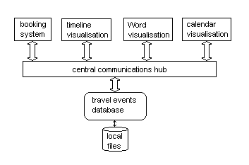

**2. Markup Languages - HTML**

**2.1 HTML Fundamentals**

* Clear text, case insensitive
* Ignores white space
* Comprised of tags <tag />
* Open tags and closed tags
* Open tags
* <name attributes/>
* <hr/>, <br/>
* <imgsrc=“url” width=‘100px’ height=’60px’/>
* Closed tags
* <name attributes> stuff </name>
* <b>text to be bolded</b>
* <h1>level 1 heading text</h1>
* Comments
* < ! - - comment text -- >

**2.2 Document Structure**

**< HTML >**

**Header**

**Body**

**< / HTML>**

**2.3 Basic Structure**

<html>

<head>

<title>The title of your html page </title>

<meta_tags/>

</head>

<body>

<! - - your web page content and markup - -></body>

</html>

**3. Cascade Styling Sheet**

**3.1 Introduction To CSS**

CSS stands for Cascading Style Sheets Styles define how to display HTML elements CSS has various levels and profiles. Each level of CSS builds upon the last, typically adding new features and typically denoted as CSS1, CSS2, and CSS3.

* The first CSS specification to become an official W3C Recommendation is CSS level 1, published in December 1996
* CSS level 2 was developed by the W3C and published as a Recommendation in May 1998. A superset of CSS1, CSS2 includes a number of new capabilities like absolute, relative, and fixed positioning of elements and z-index, the concept of media types etc.
* CSS level 3 is currently under development. The W3C maintains a CSS3 progress report.

**3.2 Understanding Style Rules**

* A Style Rule is composed of two parts: a selector and a declaration.TH {color: red;}.
* The Selector indicates the element to which the rule is applied.
* The Declaration determines the property values of a selector.
* The Property specifies a characteristic, such as color, font-family, position, and is followed by a colon (:).
* The Value expresses specification of a property, such as red for color, arial for font family, 12 pt for font-size, and is followed by a semicolon (;).
  1. **.Three Ways to Insert CSS**

**External style sheet**

* Internal style sheet
* Inline style
* External Style Sheet
* An external style sheet is ideal when the style is applied to many pages. With an external style sheet, you can change the look of an entire Web site by changing one file. Each page must link to the style sheet using the <link> tag. The <link> tag goes inside the head section

<head>  
<link rel="stylesheet" type="text/css" href="mystyle.css" />  
</head>

* An internal style sheet should be used when a single document has a unique style.

<head>  
<style type="text/css">  
hr {color:red;}  
p {margin-left:20px;}  
body {background-image:url("images/back40.gif");}  
</style>  
</head>

* An inline style sheet should be used when the property of the single tag should be uniquely designed

<p style="color:red;margin-left:20px">This is a paragraph.</p>

**4. Java Script**

**4.1 Introduction To Java Script**

* JavaScript is used in millions of Web pages to improve the design, validate forms, detect browsers, create cookies, and much more.
* JavaScript is the most popular scripting language on the internet, and works in all major browsers, such as Internet Explorer, Mozilla, Firefox, Netscape, Opera.
* JavaScript was designed to add interactivity to HTML pages
* JavaScript is a scripting language (a scripting language is a lightweight programming language)
* A JavaScript consists of lines of executable computer code
* A JavaScript is usually embedded directly into HTML pages
* JavaScript is an interpreted language (means that scripts execute without preliminary compilation)
* Everyone can use JavaScript without purchasing a license

**4.2 JavaScript Into an HTML Page**

<html>

<body>

<script type="text/javascript">

document.write("Hello World!")

</script>

</body>

</html>

**4.3 JavaScript Variables**

* Variables are used to store data.
* A variable is a "container" for information you want to store. A variable's value can change during the script. You can refer to a variable by name to see its value or to change its value.
* Rules for variable names:
* Variable names are case sensitive
* They must begin with a letter or the underscore character
* strname – STRNAME (not same)

**4.4 JavaScript Operators**

|  |  |  |  |
| --- | --- | --- | --- |
| Operator | Description | Example | Result |
| + | Addition | x=2 | 4 |
| y=2 |
| x+y |
| - | Subtraction | x=5 | 3 |
| y=2 |
| x-y |
| * | Multiplication | x=5 | 20 |
| y=4 |
| x*y |
| / | Division | 15/5 | 3 |
| 5/2 | 2,5 |
| % | Modulus (division remainder) | 5%2 | 1 |
| 10%8 | 2 |
| 10%2 | 0 |
| ++ | Increment | x=5 | x=6 |
| x++ |
| -- | Decrement | x=5 | x=4 |
| x-- |

**4.5 Introduction Of Bootstrap**

**Bootstrap** is a [free](https://en.wikipedia.org/wiki/Free_and_open-source_software) open source front-end [Framework](https://en.wikipedia.org/wiki/Application_framework) for designing [websites](https://en.wikipedia.org/wiki/Website) and [web applications](https://en.wikipedia.org/wiki/Web_application). It contains [HTML](https://en.wikipedia.org/wiki/HTML)- and [CSS](https://en.wikipedia.org/wiki/CSS)-based design templates for [typography](https://en.wikipedia.org/wiki/Typography), forms, buttons, navigation and other interface components, as well as optional [JavaScript](https://en.wikipedia.org/wiki/JavaScript)extensions. Unlike many earlier web frameworks, it concerns itself with [front-end development](https://en.wikipedia.org/wiki/Front-end_web_development) only.

Bootstrap, originally named Twitter Blueprint, was developed by Mark Otto and Jacob Thornton at [Twitter](https://en.wikipedia.org/wiki/Twitter) as a framework to encourage consistency across internal tools. Before Bootstrap, various libraries were used for interface development, which led to inconsistencies and a high maintenance burden.

Features

Bootstrap 3 supports the latest versions of the [Google Chrome](https://en.wikipedia.org/wiki/Google_Chrome), [Firefox](https://en.wikipedia.org/wiki/Firefox), [Internet Explorer](https://en.wikipedia.org/wiki/Internet_Explorer), [Opera](https://en.wikipedia.org/wiki/Opera_(web_browser)), and [Safari](https://en.wikipedia.org/wiki/Safari_(web_browser)) (except on Windows). It additionally supports back to [IE8](https://en.wikipedia.org/wiki/Internet_Explorer_8) and the latest [Firefox](https://en.wikipedia.org/wiki/Firefox) Extended Support Release (ESR).

Since 2.0, Bootstrap supports [responsive web design](https://en.wikipedia.org/wiki/Responsive_Web_Design). This means the layout of web pages adjusts dynamically, taking into account the characteristics of the device used (desktop, tablet, mobile phone).

Starting with version 3.0, Bootstrap adopted a [mobile-first design](https://en.wikipedia.org/wiki/Mobile-first_design) philosophy, emphasizing responsive design by default.

Version 4.0 added [Sass](https://en.wikipedia.org/wiki/Sass_(stylesheet_language)) and [flexbox](https://en.wikipedia.org/wiki/CSS_Flex_Box_Layout) support.

## Structure and function

## Bootstrap is modular and consists of a series of [Less](https://en.wikipedia.org/wiki/Less_(stylesheet_language)) ([Sass](https://en.wikipedia.org/wiki/Sass_(stylesheet_language)) version 4 and onward) stylesheets that implement the various components of the toolkit. These stylesheets are generally compiled into a bundle and included in web pages, but individual components can be included or removed. Bootstrap provides a number of configuration variables that control things such as color and padding of various components

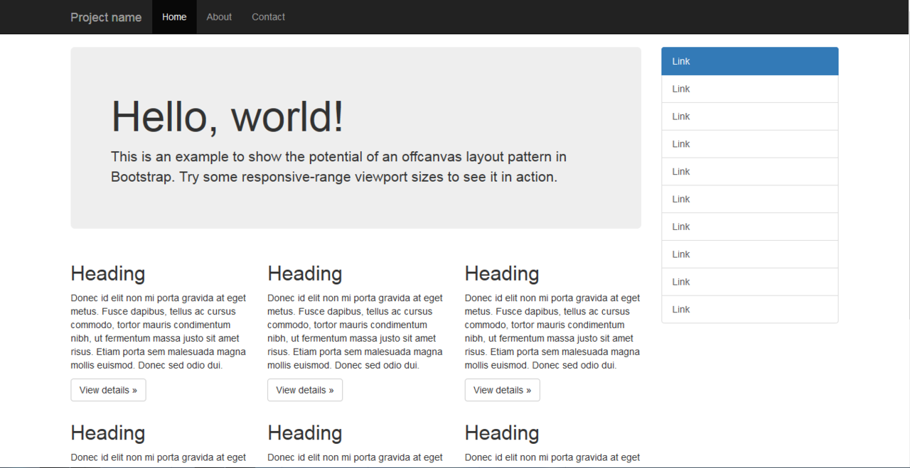

### Stylesheets

Bootstrap provides a set of stylesheets that provide basic style definitions for all key HTML components. These provide a uniform, modern appearance for formatting text, tables and form elements.

### Re-usable components

In addition to the regular HTML elements, Bootstrap contains other commonly used interface elements. The components are implemented as CSS classes, which must be applied to certain HTML elements in a page.

### JavaScript components

Bootstrap comes with several JavaScript components in the form of [jQuery](https://en.wikipedia.org/wiki/JQuery) plugins. They provide additional user interface elements such as dialog boxes, tooltips, and carousels. They also extend the functionality of some existing interface elements, including for example an auto-complete function for input fields. In version 1.3, the following JavaScript plugins are supported: Modal, Dropdown, Scrollspy, Tab, Tooltip, Popover, Alert, Button, Collapse, Carousel and Typeahead.

**Index.html**

<Html>

<head>

<title>Tourism System</title>

<link rel="stylesheet" href="css/bootstrap.min.css">

<link rel="stylesheet" href="css/main.css">

<link href="https://fonts.googleapis.com/css?family=Lobster" rel="stylesheet">

<link type="text/css" rel="stylesheet" href="css/ihover.css">

<link type="text/css" rel="stylesheet" href="css/footer.css">

<script src="js/vendor/modernizr-2.8.3-respond-1.4.2.min.js"></script>

</head>

<body>

<nav class="navbar">

<div class="container">

<button type="button" class="navbar-toggle" data-toggle="collapse" data-target="#nav1">

<span class="icon-bar"></span>

<span class="icon-bar"></span>

<span class="icon-bar"></span>

</button>

<div class="navbar-header">

<a href="#" class="navbar-brand">Tourism System</a>

</div>

<div class="collapse navbar-collapse" id="nav1">

<ul class="nav navbar-nav navbar-right">

<li class="active"><a href="index.html">Home</a></li>

<li><a href="About.html">About</a></li>

<li><a href="Domestic.html">Domestic</a></li>

<li><a href="best time to visit.html">Best Time To Visit</a></li>

<li class="dropdown">

<a href="" class="dropdown-toggle" data-target="dropdown-menu" >Pakage <span class="caret"></span></a>

<ul class="dropdown-menu">

<li><a href="#">Gold</a></li>

<li><a href="#">Silver</a></li>

<li><a href="#">Family</a></li>

</ul>

</li>

<li><a href="international.html">International</a></li>

<li><a href="gallery.html">Gallery</a></li>

<li><a href="contact.html">Contact</a></li>

<li class="get btn-info"><a href="query.html">Get Quote</a></li>

</ul>

</div>

</div>

</nav>

</div>

</div>

<div class="container">

<div class="row">

<div class="col-md-12 col-sm-12">

<h1 class="animation">WELCOME TO TOURISM SYTEM</h1></div>

</div>

<section class="feature col-sm-12 col-md-12">

<h2>About Tourism System</h2>

<p>Owing to its geographical diversity, India could be visited throughout the year. Whereas winter months from October till March are the peak season for tourism in India, monsoon is the best time to visit for enjoying p>

</section>

</div>

<section class="top col-sm-12 col-md-12">

<h2>POPULAR TOURISM PLACE</h2>

<div class="container-fluid">

<div class="row">

<div class="col-md-3 col-sm-6">

<div class="ih-item square effect6">

<a href="#">

<div class="img">

<img src="img/yc.jpeg">

</div>

<div class="info">

<h3>The Taj Mahal</h3>

<p>The Taj Mahal is an ivory-white marble mausoleum on the south bank of the Yamuna river in the Indian city of Agra. It was commissioned in 1632 by the Mughal </p>

</div>

</a>

</div>

</div>

<div class="col-md-3 col-sm-6">

<div class="ih-item square effect5">

<a href="#">

<div class="img">

<img src="img/shimla.jpeg">

</div>

<div class="info">

<h3>Simla</h3>

<p>Shimla is the capital of the northern Indian state of Himachal Pradesh, in the Himalayan foothills. Once the summer capital of British India, it remains the terminus of the narrow-gauge Kalka-Shimla Railway, completed in 1903. </p>

</div>

</a>

</div>

</div>

<div class="col-md-3 col-sm-6">

<div class="ih-item square effect7">

<a href="#">

<div class="img">

<img src="img/sikkim.jpeg">

</div>

<div class="info">

<h3>Sikkim</h3>

<p>Sikkim is a state in northeast India, bordered by Bhutan, Tibet and Nepal. Part of the Himalayas, the area has a dramatic landscape that includes India’s highest mountain, 8,586m Kangchenjunga. </p>

</div>

</a>

</div>

</div>

<div class="col-md-3 col-sm-6">

<div class="ih-item square effect5">

<a href="#">

<div class="img">

<img src="img/Goa.jpg">

</div>

<div class="info">

<h3>Goa</h3>

<p>Goa is a state in western India with coastlines stretching along the Arabian Sea. Its long history as a Portuguese colony prior to 1961 is evident in its preserved 17th-century churches and the area’s tropical spice plantations. Goa is also known for its beaches, </p>

</div>

</a>

</div>

</div>

<div class="col-md-3 col-sm-6 t">

<div class="ih-item square effect6">

<a href="#">

<div class="img">

<img src="img/darjeeling.jpg">

</div>

<div class="info">

<h3>Darjeeling</h3>

<p>Darjeeling is a town in India's West Bengal state, in the Himalayan foothills. Once a summer resort for the British Raj elite, it remains the terminus of the narrow-gauge Darjeeling Himalayan Railway, or “Toy Train,” completed in 1881. </p>

</div>

</a>

</div>

</div>

<div class="col-md-3 col-sm-6 t">

<div class="ih-item square effect6">

<a href="#">

<div class="img">

<img src="img/rajsthan.jpg">

</div>

<div class="info">

<h3>Rajsthan</h3>

<p>Rajasthan is a northern Indian state bordering Pakistan. Its palaces and forts are reminders of the many kingdoms that historically vied for the region. In its capital, Jaipur (the "Pink City"), are the 18th-century City Palace and Hawa Mahal, </p>

</div>

</a>

</div>

</div>

<div class="col-md-3 col-sm-6 t">

<div class="ih-item square effect6">

<a href="#">

<div class="img">

<img src="img/manali.jpg">

</div>

<div class="info">

<h3>Kullu Manali</h3>

<p>Manali is a high-altitude Himalayan resort town in India’s northern Himachal Pradesh state. It has a reputation as a backpacking center and honeymoon destination. Set on the Beas River, it’s a gateway for skiing in the Solang Valley and trekking in Parvati Valley. </p>

</div>

</a>

</div>

</div>

<div class="col-md-3 col-sm-6 t">

<div class="ih-item square effect6">

<a href="#">

<div class="img">

<img src="img/delhi.jpg">

</div>

<div class="info">

<h3>Delhi</h3>

<p>Delhi, India’s capital territory, is a massive metropolitan area in the country’s north. In Old Delhi, a neighborhood dating to the 1600s, stands the imposing Mughal-era Red Fort, a symbol of India, and the sprawling Jama Masjid mosque, whose courtyard accommodates 25,000 people. </p>

</div>

</a>

</div>

</div>

</div>

<br clear="all">

<section class="top col-sm-12 col-md-12 padding-left-right">

<h2>International Tour Packages by Destinations</h2>

<div class="container-fluid">

<p>A holiday in a foreign land is an everlasting memory. Who does not harbour the wish to visit a foreign land, get a chance to acquaint with the people, learn about their past, appreciate their culture and wonder at the natural and manmade creations. International holidays are no

</p>

<div class="row">

<div class="col-lg-3 col-md-3 col-sm-4">

<a href="#" class="outbound-bg">

<img src="img/thailand.jpg" width="300" height="300" alt="" class="img-responsive" style="width:100%; height:auto;" />

<span>Thailand</span>

</a>

</div>

<div class="col-lg-3 col-md-2 col-sm-4">

<a href="#" class="outbound-bg">

<img src="img/Dubai-skyline.jpg" width="300" height="300" alt="" class="img-responsive" style="width:100%; height:auto;" />

<span>Dubai</span>

</a>

</div>

<div class="col-lg-3 col-md-3 col-sm-6">

<a href="#" class="outbound-bg">

<img src="img/darjeeling.jpg" width="300" height="300" alt="" class="img-responsive" style="width:100%; height:auto;" />

<span>Darjeling</span>

</a>

</div>

<div class="col-lg-3 col-md-3 col-sm-6">

<a href="#" class="outbound-bg">

<img src="img/singapore.jpg" width="300" height="300" alt="" class="img-responsive" style="width:100%; height:auto;" />

<span>singapore</span>

</a>

</div>

</div>

<br/>

<div style="background:#f4f4f4; overflow:hidden;">

<h2 class="text-center h2-font">Places To Visit in India by Month</h2>

<br />

<ul class="list-inline text-center">

<li><a href="" class="btn btn-warning btn-lg">January</a></li>

<li><a href="" class="btn btn-warning btn-lg">February</a></li>

<li><a href="" class="btn btn-warning btn-lg">March</a></li>

<li><a href="" class="btn btn-warning btn-lg">April</a></li>

<li><a href="" class="btn btn-warning btn-lg">May</a></li>

<li><a href="" class="btn btn-warning btn-lg">June</a></li>

<li><a href="" class="btn btn-warning btn-lg">July</a></li>

<li><a href="" class="btn btn-warning btn-lg">August</a></li>

<li><a href="" class="btn btn-warning btn-lg">September</a></li>

<li><a href="" class="btn btn-warning btn-lg">October</a></li>

<li><a href="" class="btn btn-warning btn-lg">November</a></li>

<li><a href="" class="btn btn-warning btn-lg">December</a></li>

</ul>

<br />

</div>

<div class="clearfix"></div>

<div class="container">

<div class="row">

<h2 class="text-center h2-font">Recommened Packages</h2>

<br>

<div class="col-md-3 col-sm-6 theme-package theme-text" style="padding-left:10px; padding-right:10px;">

<div style="text-decoration:none;">

<a href="">

<img src="img/yc.jpeg" width="370" height="248" class="img-responsive lazy" alt="" />

<div class="theme-text-bg text-center">

<div class="theme-package-hdg"><small>Golden Triangle Tour</small></div>

<div class="theme-package-explore">7D / 6N</div>

</div>

</a>

</div>

</div>

<div class="col-md-3 col-sm-6 theme-package theme-text" style="padding-left:10px; padding-right:10px;">

<div style="text-decoration:none;">

<a href="">

<img src="img/gujj.jpg" width="370" height="258" class="img-responsive lazy" alt="" />

<div class="theme-text-bg text-center">

<div class="theme-package-hdg"><small>Gujrat Tour</small></div>

<div class="theme-package-explore">2D / 3N</div>

</div>

</a>

</div>

</div>

<div class="col-md-3 col-sm-6 theme-package theme-text" style="padding-left:10px; padding-right:10px;">

<div style="text-decoration:none;">

<a href="">

<img src="img/Madhya-Pradesh.jpg" width="370" height="248" class="img-responsive lazy" alt="" />

<div class="theme-text-bg text-center">

<div class="theme-package-hdg"><small>Madhya Pardesh Tour</small></div>

<div class="theme-package-explore">5D / 6N</div>

</div>

</a>

</div>

</div>

<div class="col-md-3 col-sm-6 theme-package theme-text" style="padding-left:10px; padding-right:10px;">

<div style="text-decoration:none;">

<a href="">

<img src="img/amritsar-tour-853.jpeg" width="370" height="248" class="img-responsive lazy" alt="" />

<div class="theme-text-bg text-center">

<div class="theme-package-hdg"><small>Amritsar Tour</small></div>

<div class="theme-package-explore">5D / 4N</div>

</div>

</a>

</div>

</div>

<br clear="all"><hr>

<br><br> <br>

--------------------------------- <!-- Footer -->------------------------------

<section id="footer">

<div class="container">

<div class="row text-center text-xs-center text-sm-left text-md-left">

<div class="col-xs-12 col-sm-4 col-md-4">

<h5>Quick links</h5>

<ul class="list-unstyled quick-links">

<li><a href="javascript:void();"><i class="fa fa-angle-double-right"></i>Home</a></li>

<li><a href="javascript:void();"><i class="fa fa-angle-double-right"></i>About</a></li>

<li><a href="javascript:void();"><i class="fa fa-angle-double-right"></i>FAQ</a></li>

<li><a href="javascript:void();"><i class="fa fa-angle-double-right"></i>Contact</a></li>

</ul>

</div>

<div class="col-xs-12 col-sm-4 col-md-4">

<h5>Information</h5>

<ul class="list-unstyled quick-links">

<li><a href="javascript:void();"><i class="fa fa-angle-double-right"></i>Product</a></li>

<li><a href="javascript:void();"><i class="fa fa-angle-double-right"></i>Tourist</a></li>

<li><a href="javascript:void();"><i class="fa fa-angle-double-right"></i>Place</a></li>

</ul>

</div> <div class="col-xs-12 col-sm-4 col-md-4">

<h5>Contact Info</h5>

<ul class="list-unstyled quick-links">

Laxmi Nagar Delhi NCR

+9123456780

</ul>

</div>

</div>

<div class="row">

<div class="col-xs-12 col-sm-12 col-md-12 mt-2 mt-sm-5">

<ul class="list-unstyled list-inline social text-center">

<li class="list-inline-item"><a href="javascript:void();"><i class="fa fa-facebook"></i></a></li>

<li class="list-inline-item"><a href="javascript:void();"><i class="fa fa-twitter"></i></a></li>

<li class="list-inline-item"><a href="javascript:void();"><i class="fa fa-instagram"></i></a></li>

<li class="list-inline-item"><a href="javascript:void();"><i class="fa fa-google-plus"></i></a></li>

<li class="list-inline-item"><a href="javascript:void();" target="_blank"><i class="fa fa-envelope"></i></a></li>

</ul>

</div>

</hr>

</div>

<div class="row">

<div class="col-xs-12 col-sm-12 col-md-12 mt-2 mt-sm-2 text-center text-white">

<p class="h6">2018 &copy All right Reversed.<a class="text-green ml-2" href="https://www.JANKARIMEDIA.INFO" target="_blank">Tourism</a></p>

<script src="//ajax.googleapis.com/ajax/libs/jquery/1.11.2/jquery.min.js"></script>

<script>window.jQuery || document.write('<script src="js/vendor/jquery-1.11.2.min.js"><\/script>')</script>

<script src="js/vendor/bootstrap.min.js"></script>

<script src="js/main.js"></script>

</body>

</html>

**Bootstrap.css**

*{margin:0px;

padding:0px;

}

body{

background-image:linear-gradient(rgba(0, 0, 0, 0.5),rgba(0, 0, 100, 0.5)), url(file:///C|/Users/NiralaTech/Desktop/Tour/img/8.jpg);

background-size:cover;

background-repeat:no-repeat;

height:100vh;

width:100%;

z-index: -10;

height: auto;

}

.navbar{

background-color:#F96;

opacity:0.8;

font-size:15px;

border-bottom:1px double #000000;

}

.navbar-nav li a{

color:#FFF;

}

.navbar-nav li a:hover{

color:#f96;

background-color:#FFF;

}

.navbar-brand{

color:#FFF;

}

.icon-bar{

background-color:#FFF;

}

.navbar-nav li.active, navbar li.active a{

background-color: #CF3;

color:#F00;

}

.get{

padding:5px;

background-color:#0F0;

font-size:20px;

border-radius:8px;

font-family:"Lucida Sans Unicode", "Lucida Grande", sans-serif;

margin-left:50px;

}

.animation {

animation: typing-text 2s steps(24), blink 0.5s infinite alternate;

overflow: hidden;

white-space: nowrap;

color:#FFF;

border-right: 3px solid #000;

text-align:center;

}

@keyframes typing-text {

from {

width: 0;

}

to {

width: 24ch;

}

}

@keyframes blink {

from {

border-color: transparent;

}

to {

border-color: #000;

}

}

.feature{

background-color:linear-gradient(rgba(0, 0, 0, 0.5),rgba(0, 0, 100, 0.5)),#FFF;

border:1px solid #00F;

border-radius:50px;}

.feature h2{

color:#C90;

margin-left:30px;

}

.feature p{

color:#FFF;

margin-left:50px;}

.top{

background-color: #CCC;

margin-top:30px;

height: auto;

}

.top h2{

color: #FFF;

text-align:center;

background-color:#C60;

font-size:40px;

}

.btn{

margin-left:80px;

color:#FFF;

padding:10px;

background-color:#03F;}

.t{

margin-top:20px;}

.padding-left-right{ padding-left:5px; padding-right:5px; }

a.outbound-bg{ background:#333; display:block; color:#FFF; text-align:center; font-size:20px; margin:15px 0 0 0px; padding:0 0 8px 0px; font-weight:bold; }

a.outbound-bg img{ margin:0 0 5px 0px; }

a.outbound-bg:hover{ color:#FF0; text-decoration:none; }

.theme-text img{ -webkit-transition:all 0.2s linear; -moz-transition:all 0.2s linear; -o-transition:all 0.2s linear; -ms-transition:all 0.2s linear; transition:all 0.2s linear; }

.theme-text .theme-colorbx{ -ms-filter:"progid: DXImageTransform.Microsoft.Alpha(Opacity=0)"; filter:alpha(opacity=0); opacity:0; background:#000; -webkit-transition:all 0.4s ease-in-out; -moz-transition:all 0.4s ease-in-out; -o-transition:all 0.4s ease-in-out; -ms-transition:all 0.4s ease-in-out; transition:all 0.4s ease-in-out; height:200px; }

.theme-text span{ -webkit-transform:translateY(100px); -moz-transform:translateY(100px); -o-transform:translateY(100px); -ms-transform:translateY(100px); transform: translateY(100px); -ms-filter:"progid: DXImageTransform.Microsoft.Alpha(Opacity=0)"; filter:alpha(opacity=0); opacity:0; -webkit-transition:all 0.2s linear; -moz-transition:all 0.2s linear; -o-transition:all 0.2s linear; -ms-transition:all 0.2s linear; transition:all 0.2s linear; }

.theme-text:hover .theme-colorbx{ -ms-filter:"progid: DXImageTransform.Microsoft.Alpha(Opacity=100)"; filter:alpha(opacity=100); opacity:1; text-decoration:none; }

.theme-text:hover span{ -ms-filter:"progid: DXImageTransform.Microsoft.Alpha(Opacity=100)"; filter:alpha(opacity=100); opacity:1; -webkit-transform:translateY(0px); -moz-transform:translateY(0px); -o-transform:translateY(0px); -ms-transform:translateY(0px); transform:translateY(0px); text-decoration:none; }

.theme-text .theme-text-bg{ position:absolute; bottom:0px; background-color:rgba(0, 0, 0, 0.7); width:93%; }

.theme-text .theme-package-hdg{ font-size:20px; color:#fff; padding:5px 0 5px 10px; }

.theme-text .theme-package-explore{ font-size:16px; color:#fff; padding-bottom:5px; text-decoration:none; padding:0 0 5px 10px; }

.theme-text a:hover .theme-package-hdg{color:#fff225 !important;}

**Bootstrap.js**

if (typeof jQuery === 'undefined') {

throw new Error('Bootstrap\'s JavaScript requires jQuery')

}

+function ($) {

var version = $.fn.jquery.split(' ')[0].split('.')

if ((version[0] < 2 && version[1] < 9) || (version[0] == 1 && version[1] == 9 && version[2] < 1)) {

throw new Error('Bootstrap\'s JavaScript requires jQuery version 1.9.1 or higher')

}

}(jQuery);

// CSS TRANSITION SUPPORT (Shoutout: http://www.modernizr.com/)

// ============================================================

function transitionEnd() {

var el = document.createElement('bootstrap')

var transEndEventNames = {

WebkitTransition : 'webkitTransitionEnd',

MozTransition : 'transitionend',

OTransition : 'oTransitionEnd otransitionend',

transition : 'transitionend'

}

for (var name in transEndEventNames) {

if (el.style[name] !== undefined) {

return { end: transEndEventNames[name] }

}

}

return false // explicit for ie8 ( ._.)

}

// COLLAPSE DATA-API

// =================

$(document).on('click.bs.collapse.data-api', '[data-toggle="collapse"]', function (e) {

var $this = $(this)

if (!$this.attr('data-target')) e.preventDefault()

var $target = getTargetFromTrigger($this)

var data = $target.data('bs.collapse')

var option = data ? 'toggle' : $.extend({}, $this.data(), { trigger: this })

Plugin.call($target, option)

})

}(jQuery);

+function ($) {

'use strict';

// DROPDOWN CLASS DEFINITION

// =========================

var backdrop = '.dropdown-backdrop'

var toggle = '[data-toggle="dropdown"]'

var Dropdown = function (element) {

$(element).on('click.bs.dropdown', this.toggle)

}

Dropdown.VERSION = '3.3.1'

Dropdown.prototype.toggle = function (e) {

var $this = $(this)

if ($this.is('.disabled, :disabled')) return

var $parent = getParent($this)

var isActive = $parent.hasClass('open')

clearMenus()

if (!isActive) {

if ('ontouchstart' in document.documentElement && !$parent.closest('.navbar-nav').length) {

// if mobile we use a backdrop because click events don't delegate

$('<div class="dropdown-backdrop"/>').insertAfter($(this)).on('click', clearMenus)

}

var relatedTarget = { relatedTarget: this }

$parent.trigger(e = $.Event('show.bs.dropdown', relatedTarget))

if (e.isDefaultPrevented()) return

$this

.trigger('focus')

.attr('aria-expanded', 'true')

$parent

.toggleClass('open')

.trigger('shown.bs.dropdown', relatedTarget)

}

return false

}

Dropdown.prototype.keydown = function (e) {

if (!/(38|40|27|32)/.test(e.which) || /input|textarea/i.test(e.target.tagName)) return

var $this = $(this)

e.preventDefault()

e.stopPropagation()

if ($this.is('.disabled, :disabled')) return

var $parent = getParent($this)

var isActive = $parent.hasClass('open')

if ((!isActive && e.which != 27) || (isActive && e.which == 27)) {

if (e.which == 27) $parent.find(toggle).trigger('focus')

return $this.trigger('click')

}

var desc = ' li:not(.divider):visible a'

var $items = $parent.find('[role="menu"]' + desc + ', [role="listbox"]' + desc)

if (!$items.length) return

var index = $items.index(e.target)

if (e.which == 38 && index > 0) index-- // up

if (e.which == 40 && index < $items.length - 1) index++ // down

if (!~index) index = 0

$items.eq(index).trigger('focus')

}

function clearMenus(e) {

if (e && e.which === 3) return

$(backdrop).remove()

$(toggle).each(function () {

var $this = $(this)

var $parent = getParent($this)

var relatedTarget = { relatedTarget: this }

if (!$parent.hasClass('open')) return

$parent.trigger(e = $.Event('hide.bs.dropdown', relatedTarget))

if (e.isDefaultPrevented()) return

$this.attr('aria-expanded', 'false')

$parent.removeClass('open').trigger('hidden.bs.dropdown', relatedTarget)

})

}

function getParent($this) {

var selector = $this.attr('data-target')

if (!selector) {

selector = $this.attr('href')

selector = selector && /#[A-Za-z]/.test(selector) && selector.replace(/.*(?=#[^\s]*$)/, '') // strip for ie7

}

var $parent = selector && $(selector)

return $parent && $parent.length ? $parent : $this.parent()

}

// DROPDOWN PLUGIN DEFINITION

// ==========================

function Plugin(option) {

return this.each(function () {

var $this = $(this)

var data = $this.data('bs.dropdown')

if (!data) $this.data('bs.dropdown', (data = new Dropdown(this)))

if (typeof option == 'string') data[option].call($this)

})

}

var old = $.fn.dropdown

$.fn.dropdown = Plugin

$.fn.dropdown.Constructor = Dropdown

// DROPDOWN NO CONFLICT

// ====================

$.fn.dropdown.noConflict = function () {

$.fn.dropdown = old

return th }

**Screenshot**

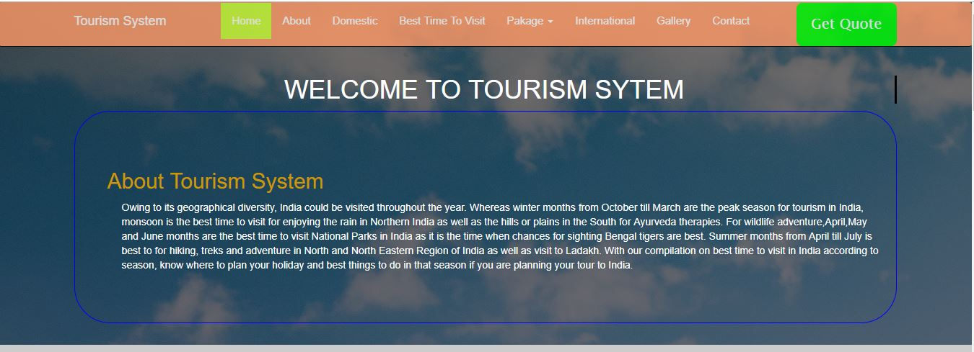

**Screenshot-2**

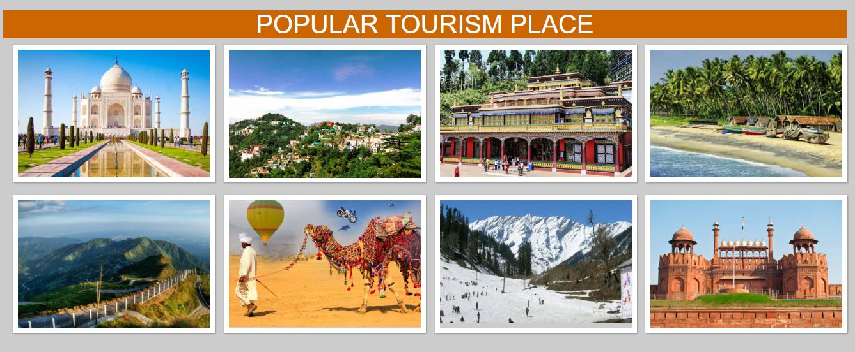

**Screenshot-3**

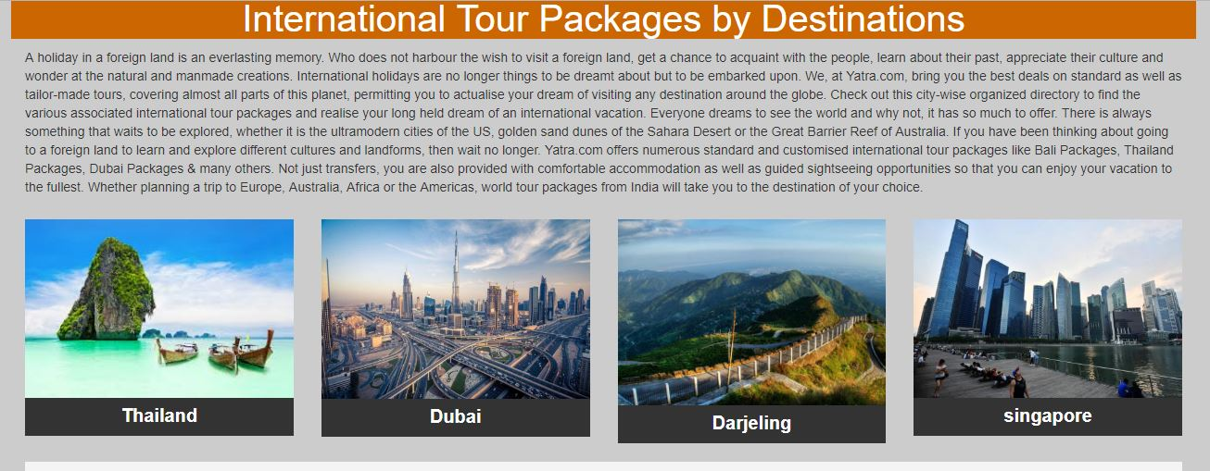

**Screenshot-4**

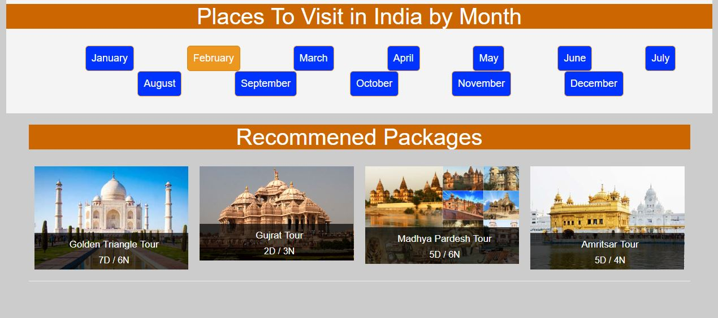

**Screenshot-5**

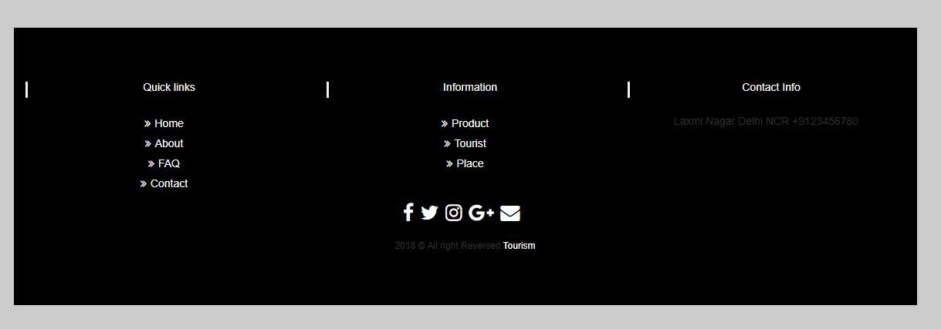

**About.html**

<!doctype html>

<html class="no-js" lang=""> <!--<![endif]-->

<head>

<meta charset="utf-8">

<title>Tourism System</title>

</head>

<style>

.body{background-color: #FFF;

border:2px solid #000;}

h2{

text-align:center;

color:#FFF;

font-size:50px;}

p{

font-size:20px;

margin-top:10px;

color: #000;

font-family:Georgia, "Times New Roman", Times, serif;}

</style>

<body>

<h2>About Us</h2>

<div class="container body">

<p>The Tourism Company was founded in 1990 by Richard Denman, Chris Evans and Steve Beioley. ... Our position in the UK The Tourism Company is well established at a national, regional and local level. ... Many of our clients are national, regional and local tourism bodies, local authorities ... <p>

<img src="img/Destination-Header.png" height="400">

</div>

</div>

**SCREENSHOT**

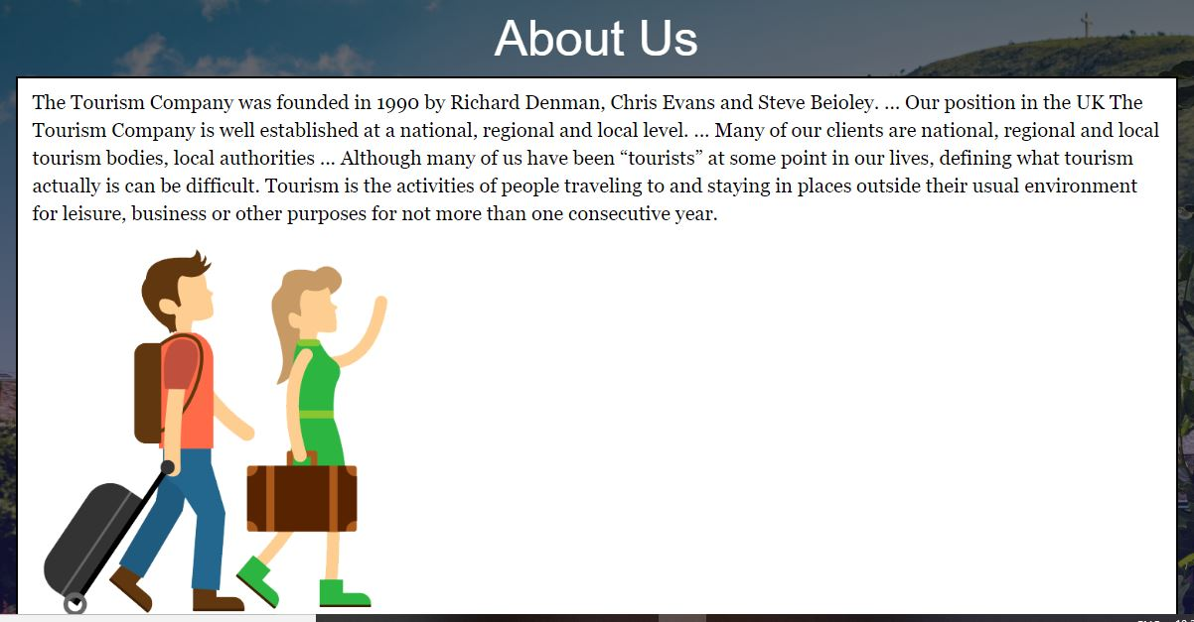

**Domestic.html**

<html>

<head>

<title>Tourism System</title>

</head>

<body>

<section class="top col-sm-12 col-md-12 padding-left-right">

<h2>National Tour Packages by Destinations</h2>

<br>

<p>Package tours are excursions or holidays which “package” a variety of services together to make a single “combined” trip. Commonly they combine such things as transport, accommodation and meals. They may also include the provision of a tour guide and/or leader. Tours can be long or short in duration and distance. They may be a one-day or overnight package, or they could be a period of a month or more</p>

<div class="container-fluid">

<div class="row">

<div class="col-lg-3 col-md-3 col-sm-4">

<a href="https://form.jotformeu.com/83272810841354" class="outbound-bg">

<img src="img/Amritsar.jpg" width="300" height="300" alt="" class="img-responsive" style="width:100%; height:auto;" />

<span>Amritsar</span>

</a>

</div>

<div class="col-lg-3 col-md-2 col-sm-4">

<a href="https://form.jotformeu.com/83272810841354" class="outbound-bg">

<img src="img/Ahemdabad.jpg" width="300" height="300" alt="" class="img-responsive" style="width:100%; height:auto;" />

<span>Ahemdabad</span>

</a>

</div>

<div class="col-lg-3 col-md-3 col-sm-6">

<a href="https://form.jotformeu.com/83272810841354" class="outbound-bg">

<img src="img/chardham_big.png" width="300" height="300" alt="" class="img-responsive" style="width:100%; height:auto;" />

<span>Chardham</span>

</a>

</div>

<div class="col-lg-3 col-md-3 col-sm-6">

<a href="https://form.jotformeu.com/83272810841354" class="outbound-bg">

<img src="img/dhramsala.webp" width="300" height="300" alt="" class="img-responsive" style="width:100%; height:auto;" />

<span>Dhramsala</span>

</a>

</div>

</div>

<div class="row">

<div class="col-lg-3 col-md-3 col-sm-4">

<a href="https://form.jotformeu.com/83272810841354" class="outbound-bg">

<img src="img/manali (1).jpg" width="300" height="300" alt="" class="img-responsive" style="width:100%; height:auto;" />

<span>Manali</span>

</a>

</div>

<div class="col-lg-3 col-md-2 col-sm-4">

<a href="https://form.jotformeu.com/83272810841354" class="outbound-bg">

<img src="img/mayamar.jpg" width="300" height="300" alt="" class="img-responsive" style="width:100%; height:auto;" />

<span>Myanmar</span>

</a>

</div>

<div class="col-lg-3 col-md-3 col-sm-6">

<a href="https://form.jotformeu.com/83272810841354" class="outbound-bg">

<img src="img/golden triangle packages.jpg" width="300" height="300" alt="" class="img-responsive" style="width:100%; height:auto;" />

<span>golden triangle packages</span>

</a>

</div>

<div class="col-lg-3 col-md-3 col-sm-6">

<a href="https://form.jotformeu.com/83272810841354" class="outbound-bg">

<img src="img/gujarat-tour-package.jpg" width="300" height="300" alt="" class="img-responsive" style="width:100%; height:auto;" />

<span>gujarat-tour-package</span>

</a>

</div>

</div>

<br clear="all"><hr>

<br><br> <br>

</body>

</html>

**SCREENSHOT**

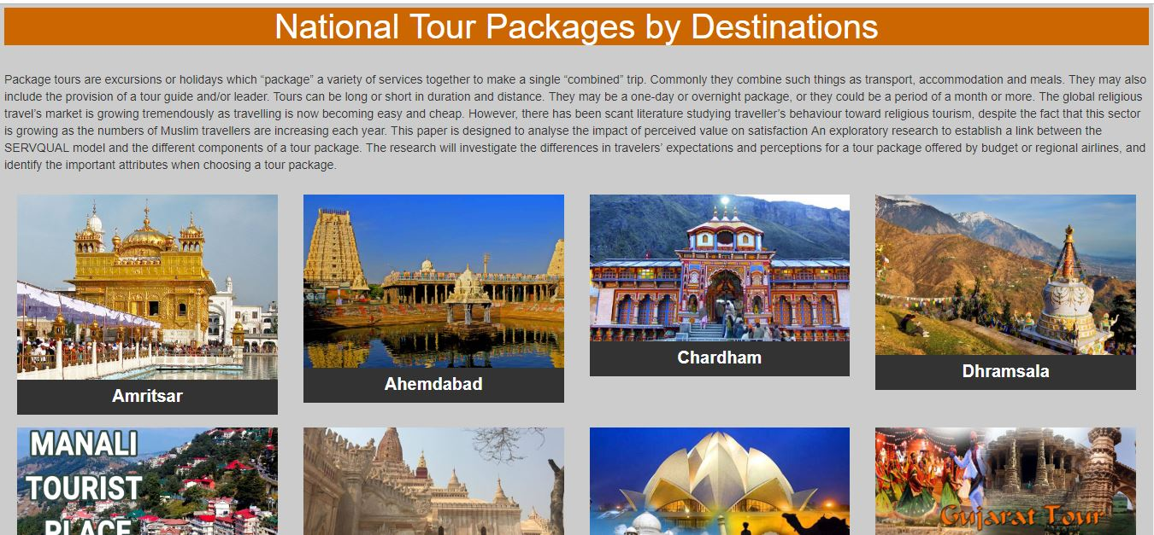

**Best time to visit.html**

<html>

<head>

<title>Tourism System</title>

</head>

<body>

<style>

.bg{

background-color:#FFF;

width:90%;}

.row 1{

background-color:#CCC;}

</style>

<body>

<div class="container-fluid bg">

<center><h1 style="color:#F63">Best Time To Visit India</h1></center>

<br>

<p> <article>Owing to its geographical diversity, India could be visited throughout the year. Whereas winter months from October till March are the peak season for tourism in India, monsoon is the best time to visit for enjoying the rain in Northern India as well as the hills or plains in the South for Ayurveda therapies. For wildlife adventure, April, May and June months are the best time to visit.</article></p>

<div class="container">

<div class="row">

<div class="col-lg-12 my-3">

<div class="pull-right">

<div class="btn-group">

<button class="btn btn-info" id="list">

List View

</button>

<button class="btn btn-danger" id="grid">

Grid View

</button>

</div>

</div>

</div>

</div>

<div id="products" class="row view-group">

<div class="item col-sm-4 col-md-4">

<div class="thumbnail card">

<div class="img-event">

<img class="group list-group-image img-fluid" src="img/golden triangle packages.jpg" width="400" height="250" alt="" />

</div>

<div class="caption card-body">

<h4 class="group card-title inner list-group-item-heading">

Golden Pack</h4>

<p class="group inner list-group-item-text">

Product description... Lorem ipsum dolor sit amet, consectetuer adipiscing elit,

sed diam nonummy nibh euismod tincidunt ut laoreet dolore magna aliquam erat volutpat.</p>

<div class="row">

<div class="item col-sm-4 col-md-4">

<p class="lead">

$20.000</p>

</div>

<div class="item col-sm-4 col-md-4">

<a class="btn btn-success" href="https://form.jotformeu.com/83272810841354">Book Now</a>

</div>

</div>

</div>

</div>

</div>

<div class="item col-sm-4 col-md-4">

<div class="thumbnail card">

<div class="img-event">

<img class="group list-group-image img-fluid" src="img/gujarat-tour-package.jpg" width="400" height="250" alt="" />

</div>

<div class="caption card-body">

<h4 class="group card-title inner list-group-item-heading">

Gujrat Tour</h4>

<p class="group inner list-group-item-text">

Product description... Lorem ipsum dolor sit amet, consectetuer adipiscing elit,

sed diam nonummy nibh euismod tincidunt ut laoreet dolore magna aliquam erat volutpat.</p>

<div class="row">

<div class="item col-sm-4 col-md-4">

<p class="lead">

$15.000</p>

</div>

<div class="item col-sm-4 col-md-4">

<a class="btn btn-success" href="https://form.jotformeu.com/83272810841354">Book Now</a>

</div>

</div>

</div>

</div>

</div>

<div class="item col-sm-4 col-md-4">

<div class="thumbnail card">

<div class="img-event">

<img class="group list-group-image img-fluid" src="img/DUBAI.jpg" width="400" height="250" alt="" />

</div>

<div class="caption card-body">

<h4 class="group card-title inner list-group-item-heading">

Dubai Package</h4>

<p class="group inner list-group-item-text">

Product description... Lorem ipsum dolor sit amet, consectetuer adipiscing elit,

sed diam nonummy nibh euismod tincidunt ut laoreet dolore magna aliquam erat volutpat.</p>

<div class="row">

<div class="item col-sm-4 col-md-4">

<p class="lead">

$30.000</p>

</div>

<div class="item col-sm-4 col-md-4">

<a class="btn btn-success" href="https://form.jotformeu.com/83272810841354">Book Now</a>

</div>

</div>

</div>

</div>

</div>

<div class="item col-sm-4 col-md-4">

<div class="thumbnail card">

<div class="img-event">

<img class="group list-group-image img-fluid" src="img/bangkok.jpg" width="400" height="250" alt="" />

</div>

<div class="caption card-body">

<h4 class="group card-title inner list-group-item-heading">

BangKok Package</h4>

<p class="group inner list-group-item-text">

Product description... Lorem ipsum dolor sit amet, consectetuer adipiscing elit,

sed diam nonummy nibh euismod tincidunt ut laoreet dolore magna aliquam erat volutpat.</p>

<div class="row">

<div class="item col-sm-4 col-md-4">

<p class="lead">

$32.000</p>

</div>

<div class="item col-sm-4 col-md-4">

<a class="btn btn-success" href="https://form.jotformeu.com/83272810841354">Book Now</a>

</div>

</div>

</div>

</div>

</div>

<div class="item col-sm-4 col-md-4">

<div class="thumbnail card">

<div class="img-event">

<img class="group list-group-image img-fluid" src="img/Europe-copy.jpg" width="400" height="250" alt="" />

</div>

<div class="caption card-body">

<h4 class="group card-title inner list-group-item-heading">

Europe</h4>

<p class="group inner list-group-item-text">

Product description... Lorem ipsum dolor sit amet, consectetuer adipiscing elit,

sed diam nonummy nibh euismod tincidunt ut laoreet dolore magna aliquam erat volutpat.</p>

<div class="row">

<div class="item col-sm-4 col-md-4">

<p class="lead">

$25.000</p>

</div>

<div class="item col-sm-4 col-md-4">

<a class="btn btn-success" href="https://form.jotformeu.com/83272810841354">Book Now</a>

</div>

</div>

</div>

</div>

</div>

<div class="item col-sm-4 col-md-4">

<div class="thumbnail card">

<div class="img-event">

<img class="group list-group-image img-fluid" src="img/malaysia-hotels-copy.jpg" width="400" height="250" alt="" />

</div>

<div class="caption card-body">

<h4 class="group card-title inner list-group-item-heading">

Malaysia Package</h4>

<p class="group inner list-group-item-text">

Product description... Lorem ipsum dolor sit amet, consectetuer adipiscing elit,

sed diam nonummy nibh euismod tincidunt ut laoreet dolore magna aliquam erat volutpat.</p>

<div class="row">

<div class="item col-sm-4 col-md-4">

<p class="lead">

$21.000</p>

</div>

<div class="item col-sm-4 col-md-4">

<a class="btn btn-success" href="https://form.jotformeu.com/83272810841354">Book Now</a>

</div>

</div>

</div>

</div>

</div>

</div>

</div>

</body>

</html>

**SCREENSHOT**

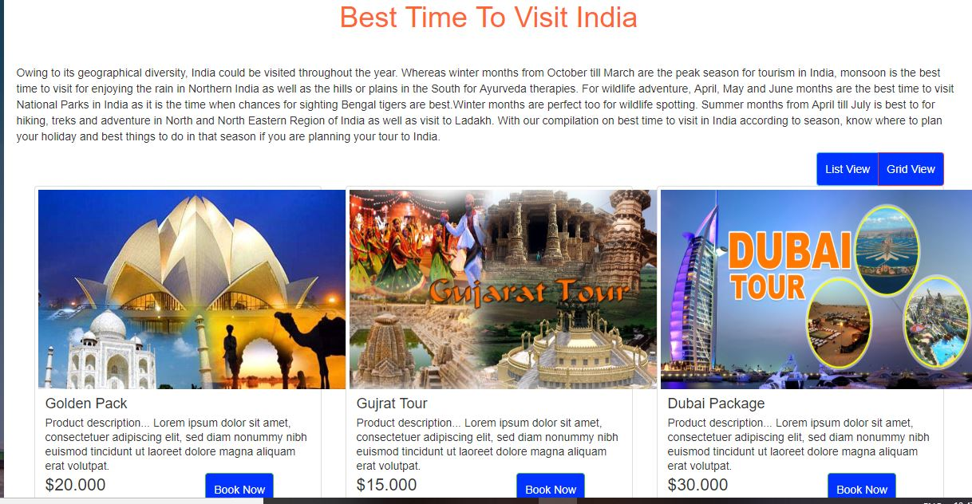

**International.html**

<html>

<head>

<title>Tourism System</title>

</head>

<body>

<section class="top col-sm-12 col-md-12 padding-left-right">

<h2>International Tour Packages by Destinations</h2>

<br>

<p>Visiting other countries can be a great experience. Whether you are traveling for work or pleasure, solo or in a group, staying for a few days or several years, planning ahead can help ensure your time abroad is both enjoyable and safe.

</p>

<center><img src="img/international-tour-packages-from-delhi.jpg" height="200"></center><hr>

<div class="row">

<div class="col-lg-3 col-md-3 col-sm-4">

<a href="#" class="outbound-bg">

<img src="img/thailand.jpg" width="300" height="300" alt="" class="img-responsive" style="width:100%; height:auto;" />

<span>Thailand</span>

</a>

</div>

<div class="col-lg-3 col-md-2 col-sm-4">

<a href="#" class="outbound-bg">

<img src="img/Dubai-skyline.jpg" width="300" height="300" alt="" class="img-responsive" style="width:100%; height:auto;" />

<span>Dubai</span>

</a>

</div>

<div class="col-lg-3 col-md-3 col-sm-6">

<a href="#" class="outbound-bg">

<img src="img/darjeeling.jpg" width="300" height="300" alt="" class="img-responsive" style="width:100%; height:auto;" />

<span>Darjeling</span>

</a>

</div>

<div class="col-lg-3 col-md-3 col-sm-6">

<a href="#" class="outbound-bg">

<img src="img/singapore.jpg" width="300" height="300" alt="" class="img-responsive" style="width:100%; height:auto;" />

<span>singapore</span>

</a>

</div>

</div>

<div class="row">

<div class="col-lg-3 col-md-3 col-sm-4">

<a href="#" class="outbound-bg">

<img src="img/paris.jpg" width="300" height="300" alt="" class="img-responsive" style="width:100%; height:auto;" />

<span>Paris</span>

</a>

</div>

<div class="col-lg-3 col-md-2 col-sm-4">

<a href="#" class="outbound-bg">

<img src="img/singapore_img-800x600.jpg" width="300" height="300" alt="" class="img-responsive" style="width:100%; height:auto;" />

<span>Singapore-Package</span>

</a>

</div>

<div class="col-lg-3 col-md-3 col-sm-6">

<a href="#" class="outbound-bg">

<img src="img/Amazing-Thailand-Tour.jpg" width="300" height="300" alt="" class="img-responsive" style="width:100%; height:auto;" />

<span>Thailand Tour Packages</span>

</a>

</div>

<div class="col-lg-3 col-md-3 col-sm-6">

<a href="#" class="outbound-bg">

<img src="img/DUBAI.jpg" width="300" height="300" alt="" class="img-responsive" style="width:100%; height:auto;" />

<span>Dubai Packages</span>

</a>

</div>

</div>

<div class="row">

<div class="col-lg-3 col-md-3 col-sm-4">

<a href="#" class="outbound-bg">

<img src="img/fazenda-praia-do-forte-BRAZILINC0716.jpg" width="300" height="300" alt="" class="img-responsive" style="width:100%; height:auto;" />

<span>BRAZILIN</span>

</a>

</div>

<div class="col-lg-3 col-md-2 col-sm-4">

<a href="#" class="outbound-bg">

<img src="img/maxresdefault-3.jpg" width="300" height="300" alt="" class="img-responsive" style="width:100%; height:auto;" />

<span>ITALY</span>

</a>

</div>

<div class="col-lg-3 col-md-3 col-sm-6">

<a href="#" class="outbound-bg">

<img src="img/malaysia-hotels-copy.jpg" width="300" height="300" alt="" class="img-responsive" style="width:100%; height:auto;" />

<span>Malaysia</span>

</a>

</div>

<div class="col-lg-3 col-md-3 col-sm-6">

<a href="#" class="outbound-bg">

<img src="img/Europe-copy.jpg" width="300" height="300" alt="" class="img-responsive" style="width:100%; height:auto;" />

<span>EUROP-PACKAGES</span>

</a>

</div>

</div>

<br clear="all"><hr>

<br><br> <br>

</body>

</html>

**Screenshot**

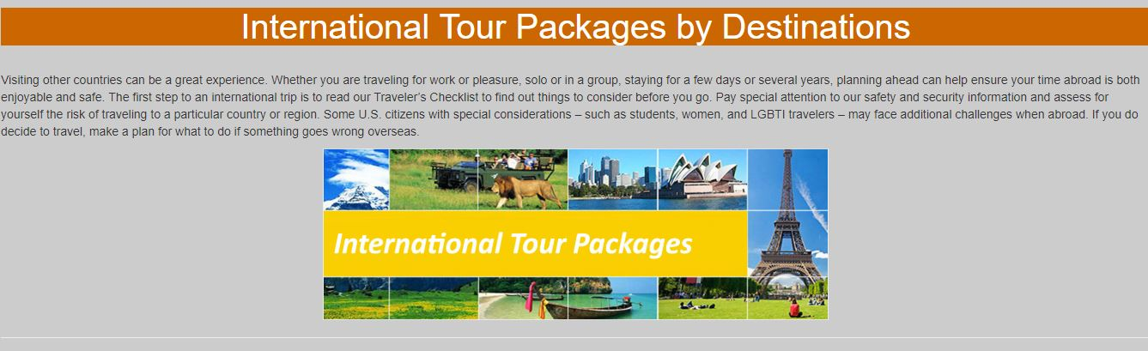

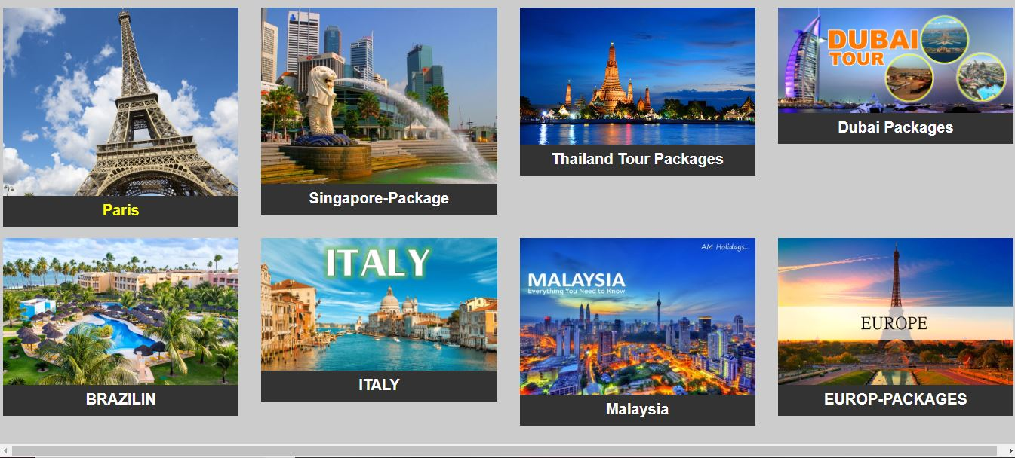

**Gallery.html**

<html>

<head>

<title>Tourism System</title>

</head>

<style>

.hide-bullets {

list-style:none;

margin-left: -40px;

margin-top:20px;

}

.thumbnail {

padding: 0;

}

.carousel-inner>.item>img, .carousel-inner>.item>a>img {

width: 100%;

}

</style>

<body>

<div class="container">

<div id="main_area">

<!-- Slider -->

<div class="row">

<div class="col-sm-6" id="slider-thumbs">

<!-- Bottom switcher of slider -->

<ul class="hide-bullets">

<li class="col-sm-3">

<a class="thumbnail" id="carousel-selector-0">

<img src="img/amritsar-tour-853.jpeg">

</a>

</li>

<li class="col-sm-3">

<a class="thumbnail" id="carousel-selector-1">

<img src="img/24-800x600.jpg"></a>

</li>

<li class="col-sm-3">

<a class="thumbnail" id="carousel-selector-2"><img src="img/Ahemdabad.jpg"></a>

</li>

<li class="col-sm-3">

<a class="thumbnail" id="carousel-selector-3"><img src="img/Amazing-Thailand-Tour.jpg"></a>

</li>

<li class="col-sm-3">

<a class="thumbnail" id="carousel-selector-4"><img src="img/australia.jpg"></a>

</li>

<li class="col-sm-3">

<a class="thumbnail" id="carousel-selector-5"><img src="img/bangkok.jpg"></a>

</li>

<li class="col-sm-3">

<a class="thumbnail" id="carousel-selector-6"><img src="img/chardham_big.png"></a>

</li>

<li class="col-sm-3">

<a class="thumbnail" id="carousel-selector-7"><img src="img/darjeeling.jpg"></a>

</li>

<li class="col-sm-3">

<a class="thumbnail" id="carousel-selector-8"><img src="img/delhi.jpg"></a>

</li>

<li class="col-sm-3">

<a class="thumbnail" id="carousel-selector-9"><img src="img/Dubai-skyline.jpg"></a>

</li>

<li class="col-sm-3">

<a class="thumbnail" id="carousel-selector-10"><img src="img/golden triangle packages.jpg"></a>

</li>

<li class="col-sm-3">

<a class="thumbnail" id="carousel-selector-11"><img src="img/flight-tickets-booking.jpg"></a>

</li>

<li class="col-sm-3">

<a class="thumbnail" id="carousel-selector-12"><img src="img/gujarat-tour-package.jpg"></a>

</li>

<li class="col-sm-3">

<a class="thumbnail" id="carousel-selector-13"><img src="img/malaysia-hotels-copy.jpg"></a>

</li>

<li class="col-sm-3">

<a class="thumbnail" id="carousel-selector-14"><img src="img/shimla.jpeg"></a>

</li>

<li class="col-sm-3">

<a class="thumbnail" id="carousel-selector-15"><img src="img/manali.jpg"></a>

</li>

</ul>

</div>

<div class="col-sm-6">

<div class="col-xs-12" id="slider">

<!-- Top part of the slider -->

<div class="row">

<div class="col-sm-12" id="carousel-bounding-box">

<div class="carousel slide" id="myCarousel">

<!-- Carousel items -->

<div class="carousel-inner">

<div class="active item" data-slide-number="0">

<img src="img/international-tours-europe.jpg"></div>

<div class="item" data-slide-number="1">

<img src="img/manali (1).jpg"></div>

<div class="item" data-slide-number="2">

<img src="img/singapore_img-800x600.jpg"></div>

<div class="item" data-slide-number="3">

<img src="img/malaysia-hotels-copy.jpg"></div>

<div class="item" data-slide-number="4">

<img src="img/rajsthan.jpg"></div>

<div class="item" data-slide-number="5">

<img src="http://placehold.it/470x480&text=5"></div>

<div class="item" data-slide-number="6">

<img src="img/Ahemdabad.jpg"></div>

<div class="item" data-slide-number="7">

<img src="img/fazenda-praia-do-forte-BRAZILINC0716.jpg"></div>

<div class="item" data-slide-number="8">

<img src="img/Amazing-Thailand-Tour.jpg"></div>

<div class="item" data-slide-number="9">

<img src="img/manali.jpg"></div>

<div class="item" data-slide-number="10">

<img src="img/Europe-copy.jpg"></div>

<div class="item" data-slide-number="11">

<img src="img/Madhya-Pradesh.jpg"></div>

<div class="item" data-slide-number="12">

<img src="img/kerala.jpg"></div>

<div class="item" data-slide-number="13">

<img src="img/singapore.jpg"></div>

<div class="item" data-slide-number="14">

<img src="http://placehold.it/470x480&text=14"></div>

<div class="item" data-slide-number="15">

<img src="img/8.jpg"></div>

</div>

<!-- Carousel nav -->

<a class="left carousel-control" href="#myCarousel" role="button" data-slide="prev">

<span class="glyphicon glyphicon-chevron-left"></span>

</a>

<a class="right carousel-control" href="#myCarousel" role="button" data-slide="next">

<span class="glyphicon glyphicon-chevron-right"></span>

</a>

</div>

</div>

</div>

</div>

</div>

</div>

</div>

</body>

</html>

**SCREENSHOT**

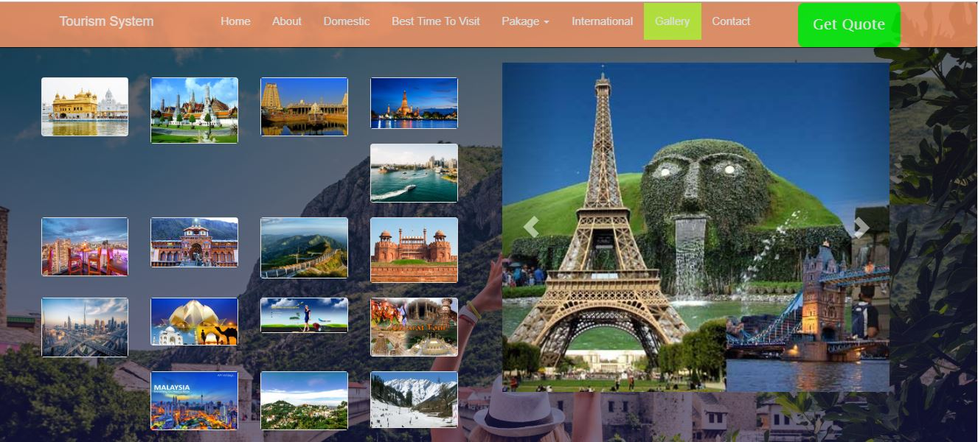

**Contact.html**

<html>

<head>

<title>Tourism System</title>

</head>

<style>

@import url("https://maxcdn.bootstrapcdn.com/font-awesome/4.7.0/css/font-awesome.min.css");

/*Google font integration*/

@import url('https://fonts.googleapis.com/css?family=Roboto');

#contact{

background-color:#f1f1f1;

font-family: 'Roboto', sans-serif;

}

#contact .well{

margin-top:30px;

border-radius:0;

}

#contact .form-control{

border-radius: 0;

border:2px solid #1e1e1e;

}

#contact button{

border-radius:0;

border:2px solid #1e1e1e;

}

#contact .row{

margin-bottom:30px;

}

@media (max-width: 768px) {

#contact iframe {

margin-bottom: 15px;

}

}

</style>

<body>

<section id="contact">

<div class="container">

<div class="well well-sm">

<h3><strong>Contact Us</strong></h3>

</div>

<div class="row">

<div class="col-md-7">

<iframe src="https://www.google.com/maps/embed?pb=!1m10!1m8!1m3!1d3736489.7218514383!2d90.21589792292741!3d23.857125486636733!3m2!1i1024!2i768!4f13.1!5e0!3m2!1sen!2sbd!4v1506502314230" width="100%" height="315" frameborder="0" style="border:0" allowfullscreen></iframe>

</div>

<div class="col-md-5">

<h4><strong>Get in Touch</strong></h4>

<form>

<div class="form-group">

<input type="text" class="form-control" name="" value="" placeholder="Name">

</div>

<div class="form-group">

<input type="email" class="form-control" name="" value="" placeholder="E-mail">

</div>

<div class="form-group">

<input type="tel" class="form-control" name="" value="" placeholder="Phone">

</div>

<div class="form-group">

<textarea class="form-control" name="" rows="3" placeholder="Message"></textarea>

</div>

<button class="btn btn-default" type="submit" name="button">

<i class="fa fa-paper-plane-o" aria-hidden="true"></i> Submit

</button>

</form>

</div>

</div>

</body>

</html>

**SCREENSHOT**

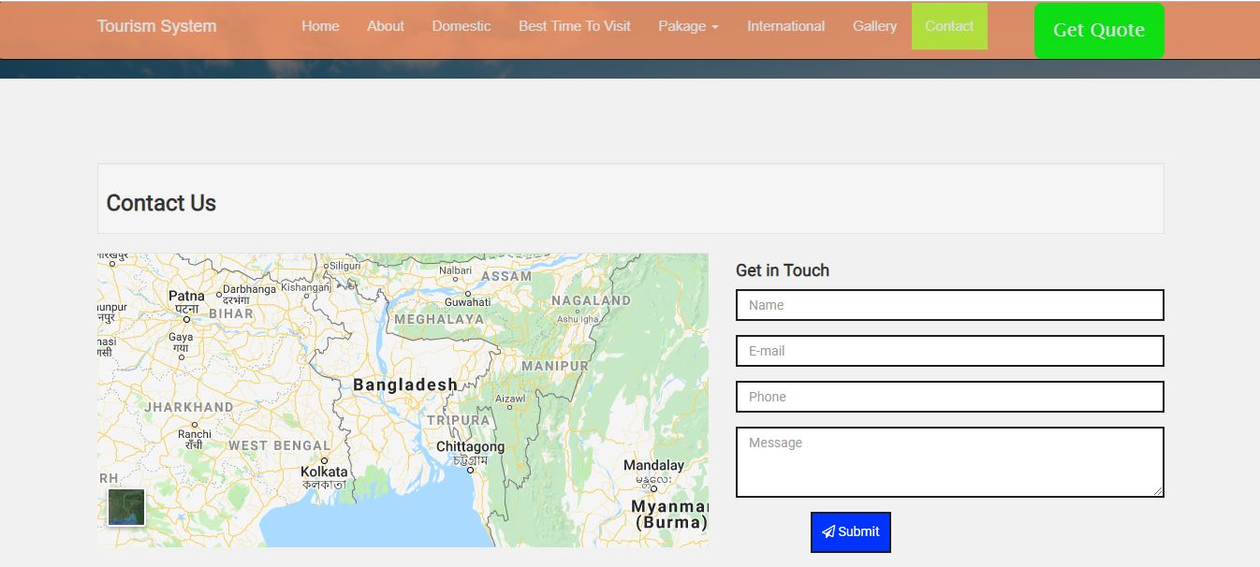

**Query.html**

<html>

<head>

<title>Tourism system</title>

</head>

<style>

img {width:100%;

}

.s{

background-color:#FFF;

height:500px;

border-radius:10%;}

</style>

<body>

<section class="testimonial py-5 s" id="testimonial">

<div class="container">

<div class="row ">

<div class="col-md-4 py-5 bg-primary text-white text-center ">

<div class=" ">

<div class="card-body">

<img src="img/flight-tickets-booking.jpg" style="width:50%">

<h2 class="py-3">Get Query</h2>

<p>Tation argumentum et usu, dicit viderer evertitur te has. Eu dictas concludaturque usu, facete detracto patrioque an per, lucilius pertinacia eu vel.

</p>

</div>

</div>

</div>

<div class="col-md-8 py-5 border">

<h4 class="pb-4">Please fill with your details</h4>

<form>

<div class="form-row">

<div class="form-group col-md-6">

<input id="Full Name" name="Full Name" placeholder="Full Name" class="form-control" type="text">

</div>

<div class="form-group col-md-6">

<input type="email" class="form-control" id="inputEmail4" placeholder="Email">

</div>

</div>

<div class="form-row">

<div class="form-group col-md-6">

<input id="Mobile No." name="Mobile No." placeholder="Mobile No." class="form-control" required type="text">

</div>

<div class="form-group col-md-6">

<select id="inputState" class="form-control">

<option selected>Choose ...</option>

<option> New Buyer</option>

<option> Auction</option>

<option> Complaint</option>

<option> Feedback</option>

</select>

</div>

<div class="form-group col-md-12">

<textarea id="comment" name="comment" cols="40" rows="5" class="form-control"></textarea>

</div>

</div>

<div class="form-row">

<div class="form-group">

<div class="form-group">

<div class="form-check">

<input class="form-check-input" type="checkbox" value="" id="invalidCheck2" required>

<label class="form-check-label" for="invalidCheck2">

<small>By clicking Submit, you agree to our Terms & Conditions, Visitor Agreement and Privacy Policy.</small>

</label>

</div>

</div>

</div>

</div>

<div class="form-row">

<button type="button" class="btn btn-danger">Submit</button>

</div>

</form>

</div>

</div>

</div>

</div>

</section>

</body>

</html>

**SCREENSHOT**

